**## Installation**

# Typo3 Projekt

# ### Prepare environment

* install specific version of apache and php for selected typo3 version

For selected version of Typo3 we need Docker.

https://docs.docker.com/desktop/install/mac-install/

* install ddev in terminal:

install homebrew in Terminal

<https://ddev.readthedocs.io/en/stable/users/install/ddev-installation/>

*or install script in terminal

<https://ddev.readthedocs.io/en/stable/users/install/ddev-installation/>

*go get.typo3.org

Select your version download and install.

Ein Bild, das Text, Screenshot, Software, Website enthält.

* adjust php and apache configurations:

-----------PHP Konfiguarationsdatei ---------------- c:\xampp\php\php.ini

memory_limit=256M max_execution_time=240 max_input_vars=1500 post_max_size = 10M upload_max_filesize = 10M

Required Extensions

extension=fileinfo extension=intl extension=openssl

opcache:

opcache.enable=1 opcache.revalidate_freq=30 opcache.revalidate_path=0

------------ APACHE Konfigurationsdatei -------------

Append following lines to:

c:\xampp\apache\conf\httpd.conf

### TYPO3 Einstellung

<IfModule mpm_winnt_module> ThreadStackSize 8388608

</IfModule>

# ## Create a new instance of typo3

Open terminal as administrator.

*make a test folder in your root folder

mkdir demo_typo3

*and navigate your project folder

cd demo_typo3

*start docker

*go typo 3 doc with your browser

*select installing typo3

*Select Execute Composer Create-Project/ddev

Copy that commend and past your terminal under your test typo3 folder

Ein Bild, das Text, Screenshot, Website, Software enthält.

ddev config --project-type=typo3 --docroot=public --create-docroot --php-version 8.1

ddev composer create "typo3/cms-base-distribution:^12"

*configuration setting

* *Depending on your DDEV version the configuration file may have been*
* *# created in an outdated location, you can move it with*
* mkdir -p config/system/ && mv public/typo3conf/AdditionalConfiguration.php $_/additional.php

*start ddev

ddev start

Ein Bild, das Text, Screenshot, Software, Webseite enthält.

*start browser

Go your page in terminal with commend ddev launch

* as prompted, you must create a file named FIRST_INSTALL to allow setup in current folder or subdomain.

Make under public folder a FIRST_INSTALL file without extension.

* Follow installation steps

create new database (e.g. cms8, Admin_123) using typo3 installer UI

# ## Using Typo3 backend

After the installation is complete you can login to your new installation/instance.

Enter your credentials here:

Ein Bild, das Text, Screenshot, Schrift, Zahl enthält.

Ein Bild, das Screenshot, Text, Software, Webseite enthält.

After some search it turnes out the database had difficulties starting. So after restart of a DB it started to work. What are the possibilities to resolve such problems without clueless search? Typo3 does not give one a hint.

Then you can create a new page in newly opened backend. Under page. Make it visible. Then create a template for this page. Under template menu in typo3 backend.

An example of simple page definition using the second provided template:

# PAGE and FLUIDTEMPLATE objects: page = PAGE

page.includeCSS.main = fileadmin/css/style.css page.includeCSS.main.title = main page.includeCSS.main.media = all page.includeJSFooter.main = fileadmin/javascript/main.js page.10 = FLUIDTEMPLATE

page.10.file = fileadmin/templates/template3.html page.10 {

variables { brandLineFirst = TEXT

brandLineFirst.value = Snowboardschule brandLineSecond = TEXT

brandLineSecond.value = Meyer, Müller & Schmidt contentMain < styles.content.get

}

}

With this template this snowboardschule page looks like this on a mobile view (smaller screens):

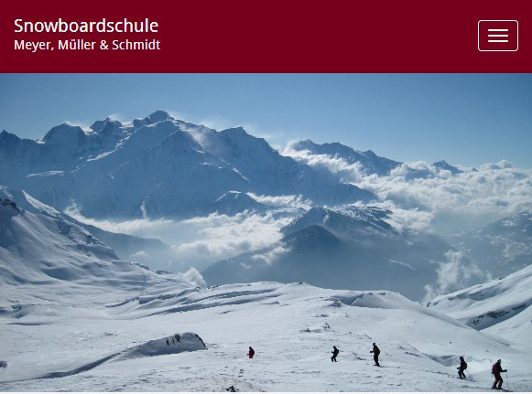

And like this on bigger screens like monitors:



It is possible to add content to the page. For this use Page menu element and add content using button „+ content“. You can add text, text+image and other types of content.

After this is done and you added your content there. It is not enough. It is even not enough if you use standard content variables in a fluid template.

One more step is required in typo3. Under template for given page you need to switch to „Includes“ tab. There you have to add fluid content elements out of available items. See the picture below:

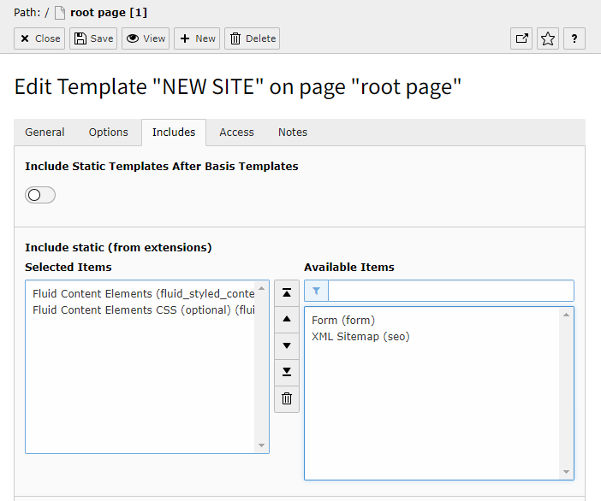

After this is done, mobile version looks like this:

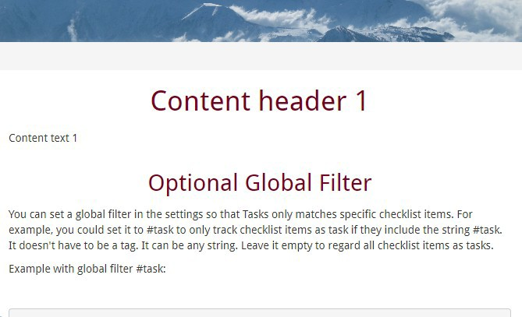

And the full desktop version of this page looks like this:

